Classification using K-Nearest Neighbors (KNN) and Decision Tree
K NEAREST NEIGHBOR - Predicting whether a tumour is benign or malignant based on medical measurements:
Confusion matrix:
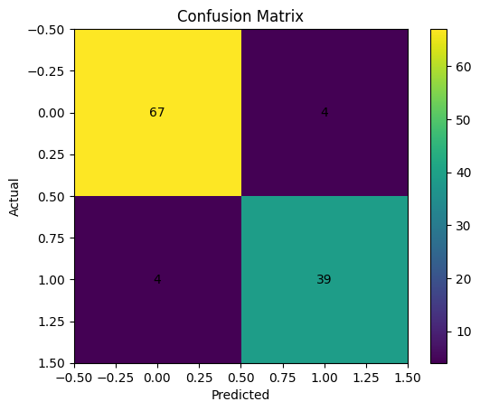
Accuracy vs K:
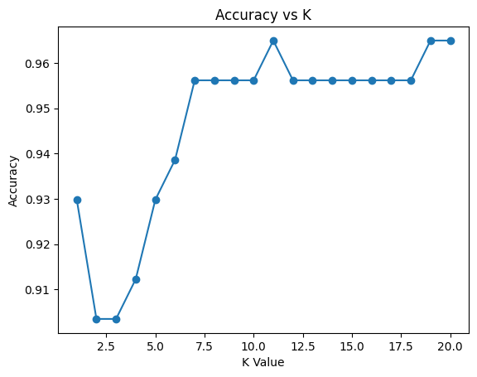
Decision Boundary:
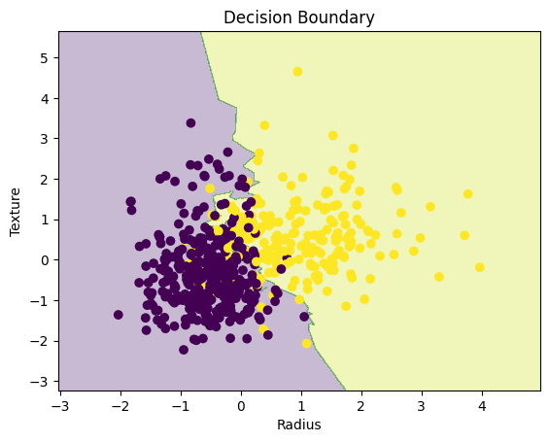

DECISION TREE CLASSIFIER - Predicting whether a loan application should be approved or rejected:
Confusion matrix:
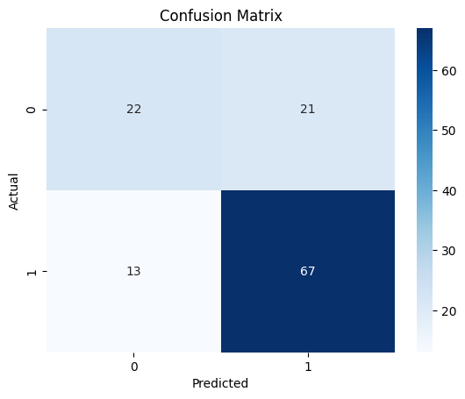
Decision Tree:
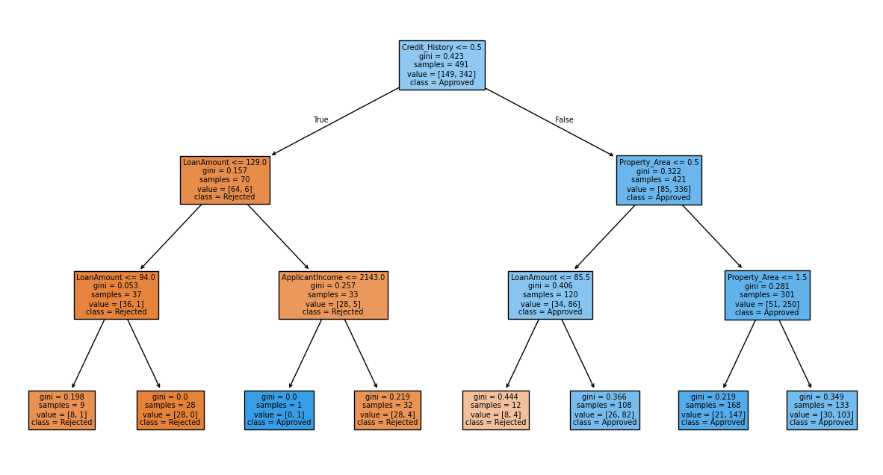
Feature importance:
